Introduction to Therapy Dog Skills Session 3 • 11 AM Saturdays

**Classes held on 4-23, 4-30, 5-7 & 5-14**

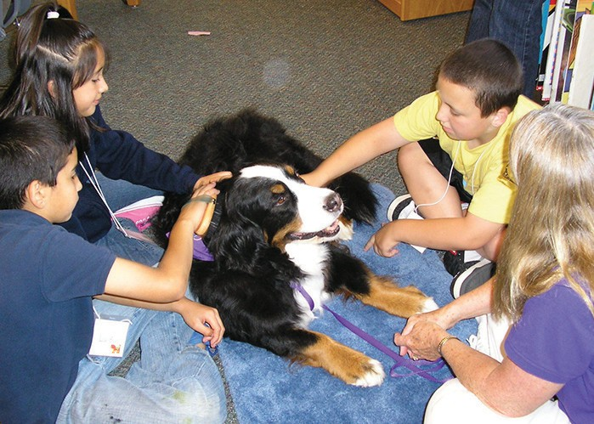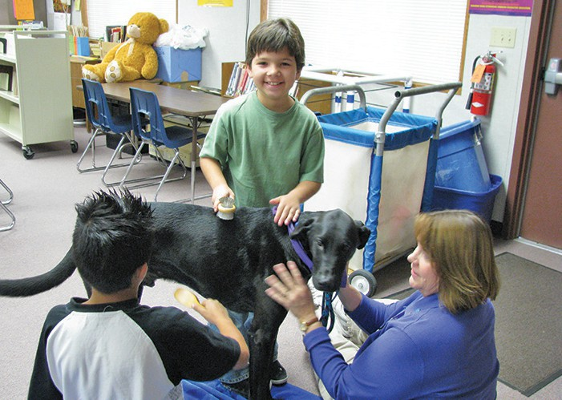

**Prerequisites:**

Handlers must be at least 18 years of age.

Dog must be at least 1 year of age and successfully completed Good Manners 1 as a mini- mum. Completion of Good Manners 2 or equivalent is recommended. Dog must know: Sit & Sit-Stay, Down & Down-Stay, Leave It, Watch Me, Hand Touch and Walk Politely on Leash.

All dogs must be people and dog friendly.

This four-week class focuses on skills dogs and handlers need to work well together when visiting people in facilities. Owners will gain understanding of animal- assisted therapy, safety issues and the tools to become an effective therapy team.

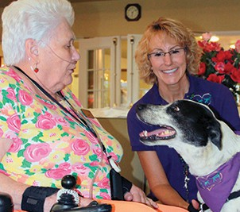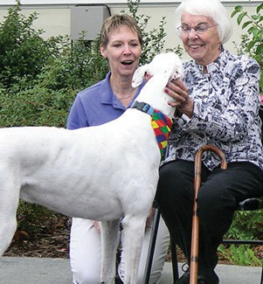**SKILLS TAUGHT:** Useful verbal cues and hand signals, heeling on both sides, cut/pass/flip, using a stool/mat, exposure to healthcare equipment and distractions, and more.

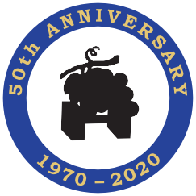

Completion of this class will **not** include registration/certification as a therapy dog or team.



**Online registration opens 3/14 & closes 4/4: nvdtc.org/registration.htm**

**Questions?** [**registration@nvdtc.org**](mailto:registration@nvdtc.org)

**Classes are held at Napa Valley Dog Training Club.**

68 Coombs Street, Bldg. N • nvdtc.org • Napa, California

# Introduction to Therapy Dog Skills Session 3 • 11 AM Saturdays

**Classes held on 4-23, 4-30, 5-7 & 5-14**

# Introduction to Therapy Dog Skills Session 3 • 11 AM Saturdays

**Classes held on 4-23, 4-30, 5-7 & 5-14**

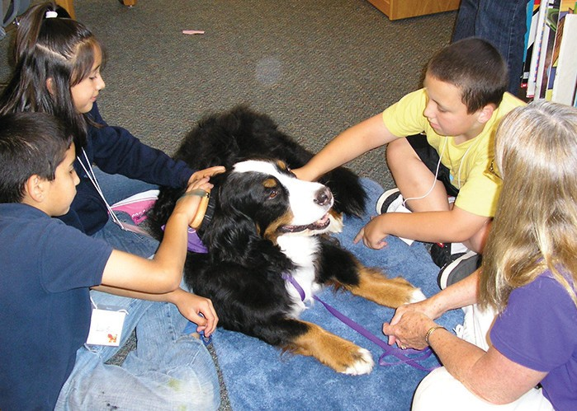 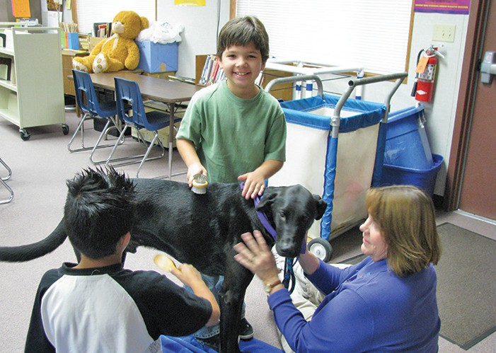  

### Prerequisites:

Handlers must be at least 18 years of age.

Dog must be at least 1 year of age and successfully completed Good Manners 1 as a mini- mum. Completion of Good Manners 2 or equivalent is recommended. Dog must know: Sit & Sit-Stay, Down & Down-Stay, Leave It, Watch Me, Hand Touch and Walk Politely on Leash.

All dogs must be people and dog friendly.

This four-week class focuses on skills dogs and handlers need to work well together when visiting people in facilities. Owners will gain understanding of animal- assisted therapy, safety issues and the tools to become an effective therapy team.

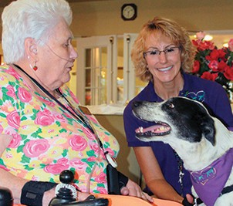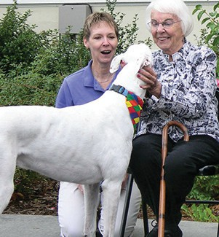**SKILLS TAUGHT:** Useful verbal cues and hand signals, heeling on both sides, cut/pass/flip, using a stool/mat, exposure to healthcare equipment and distractions, and more.



### Prerequisites:

Handlers must be at least 18 years of age.

Dog must be at least 1 year of age and successfully completed Good Manners 1 as a mini- mum. Completion of Good Manners 2 or equivalent is recommended. Dog must know: Sit & Sit-Stay, Down & Down-Stay, Leave It, Watch Me, Hand Touch and Walk Politely on Leash.

All dogs must be people and dog friendly.

This four-week class focuses on skills dogs and handlers need to work well together when visiting people in facilities. Owners will gain understanding of animal- assisted therapy, safety issues and the tools to become an effective therapy team.

**SKILLS TAUGHT:** Useful verbal cues and hand signals, heeling on both sides, cut/pass/flip, using a stool/mat, exposure to healthcare equipment and distractions, and more.



## Completion of this class will **not** include registration/certification as a therapy dog or team.

Completion of this class will **not** include registration/certification as a therapy dog or team.



**Online registration opens 3/14 & closes 4/4: nvdtc.org/registration.htm**

**Questions?** [**registration@nvdtc.org**](mailto:registration@nvdtc.org)



**Online registration opens 3/14 & closes 4/4: nvdtc.org/registration.htm**

**Questions?** [**registration@nvdtc.org**](mailto:registration@nvdtc.org)

**Classes are held at Napa Valley Dog Training Club.**

## 68 Coombs Street, Bldg. N • nvdtc.org • Napa, California

www..com • (707) 253-8666

**Classes are held at Napa Valley Dog Training Club.**

## 68 Coombs Street, Bldg. N • nvdtc.org • Napa, California

www..com • (707) 253-8666